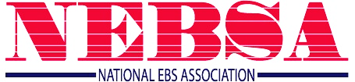

Suggested Talking Points for Congressional Interactions:

- Provide background on your institution and history with EBS.

- Tout that EBS is a success story. EBS has made programs like yours possible. Share an example of how EBS has benefited your institution and/or reiterate your comments filed in the NPRM proceeding.

- If Leasing – Share how EBS is an excellent example of the benefits of public/private partnerships.

- Explain “the ask”. The educational community is seeking Congressional support for a letter to the FCC to preserve the educational nature of EBS:
  - Retain eligibility requirements (to hold a license)
  - Support proposed application-filing windows giving priority assignment to Native American Tribes and educational entities.

- EBS should continue to be reserved for education to ensure programs like yours continue, and more educational entities - particularly those in rural communities - have the chance to replicate its success.

- Encourage he/she sign the letter. You fully support Representative/Senator XXXX signing this letter.

